**EXPERIMENT : 9**

**SOFTWARE MANAGEMENT SYSTEM**

USE CASE DIAGRAM

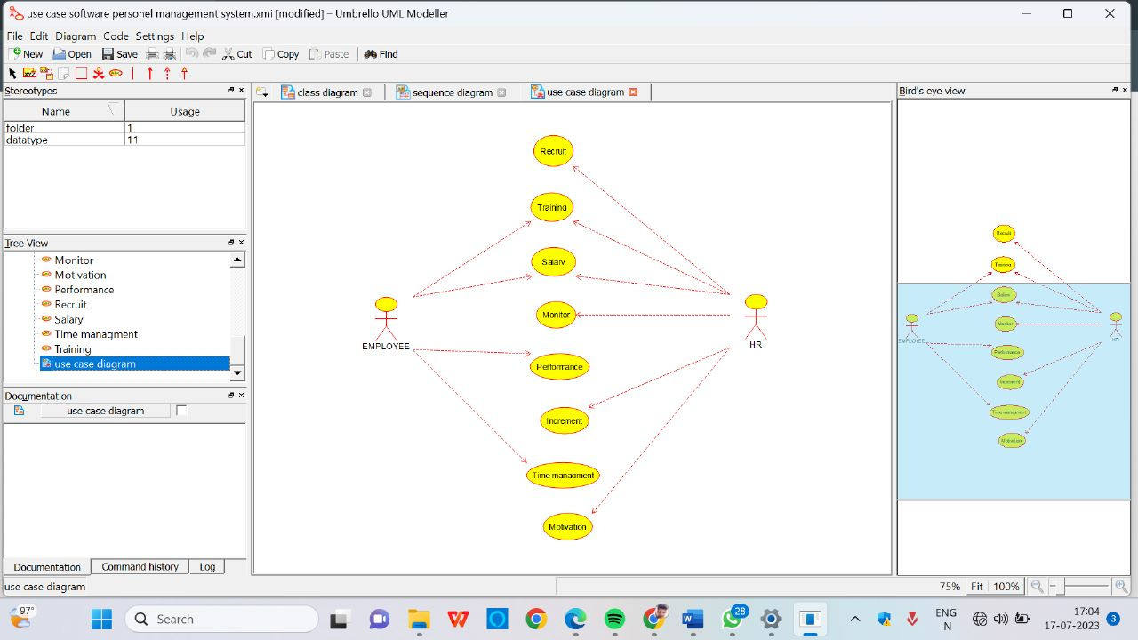

SEQUENCE DIAGRAM

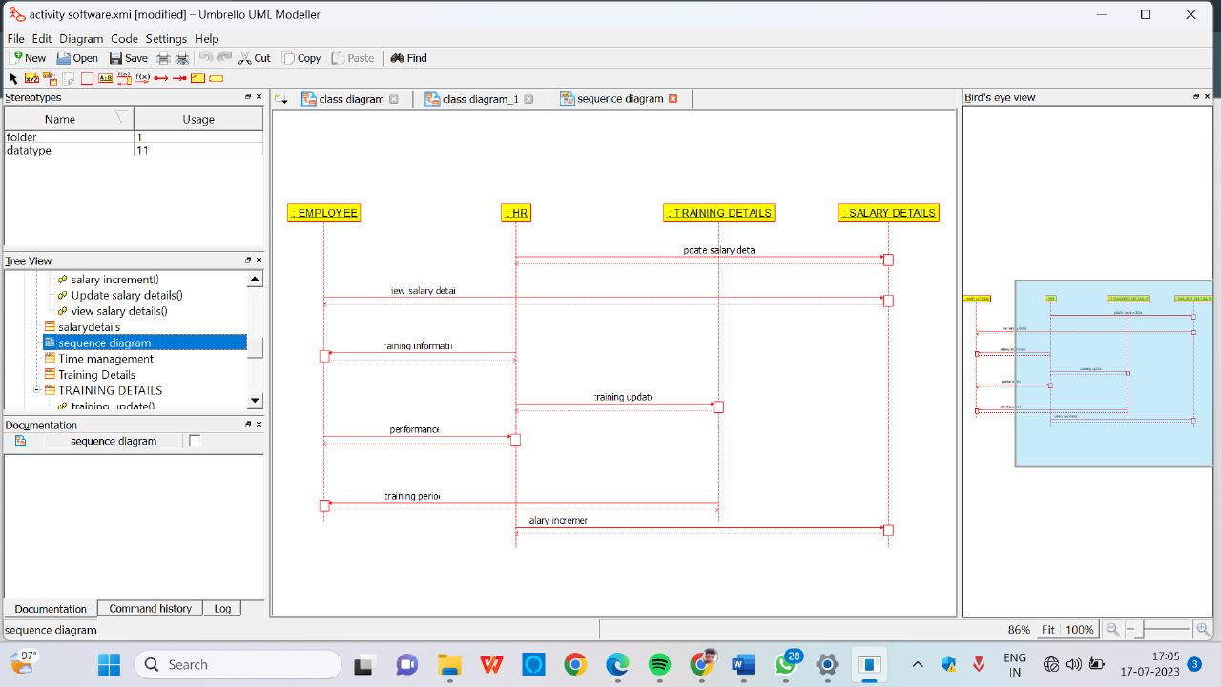

ACTIVITY DIAGRAM

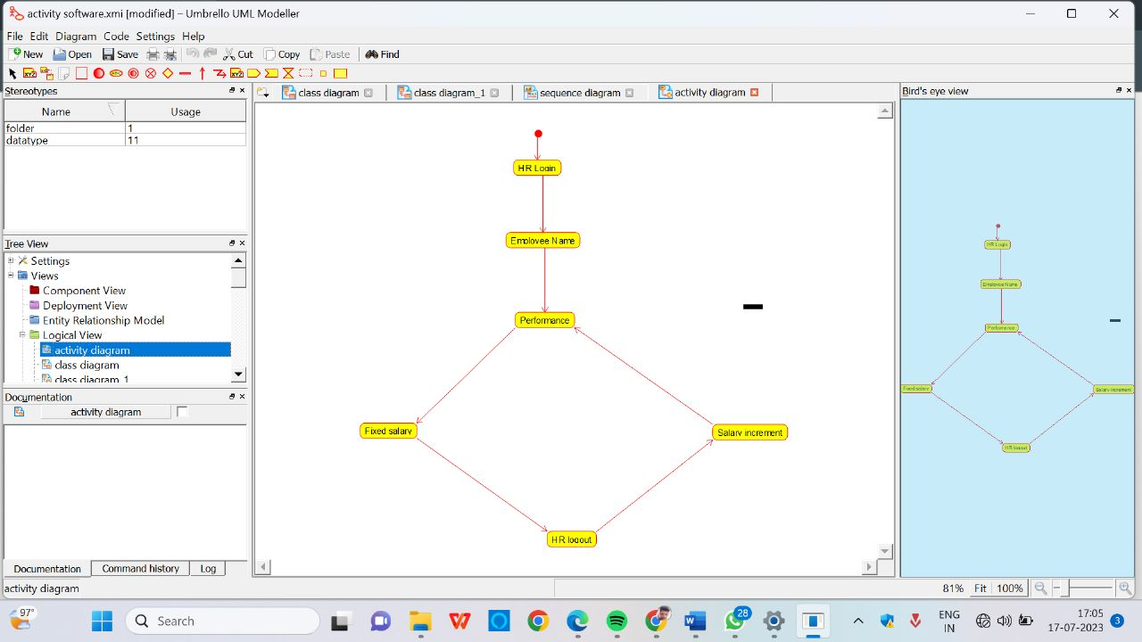

CLASS DIAGRAM

